**DC 3**

Thevenin – Helmholtz and Norton Theorems

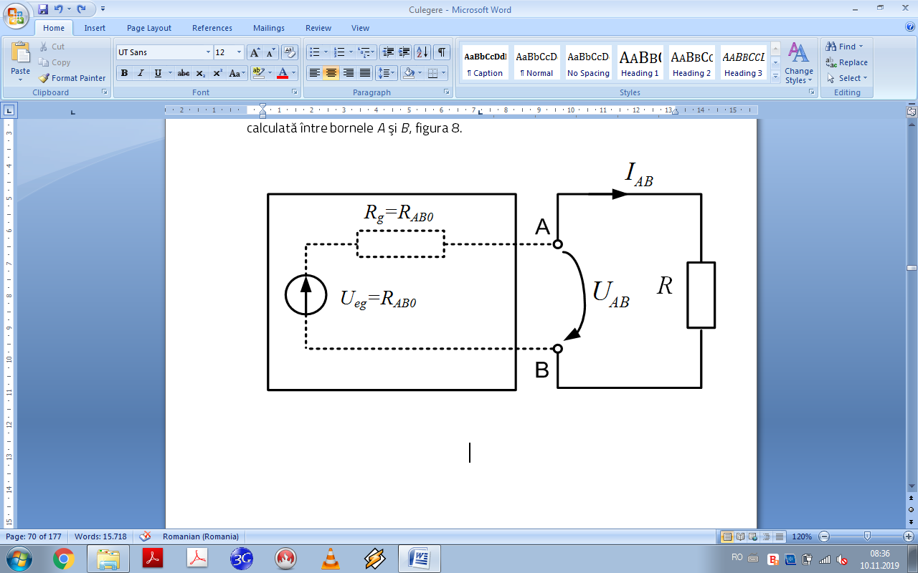

**Fig. 1.** Thevenin Theorem



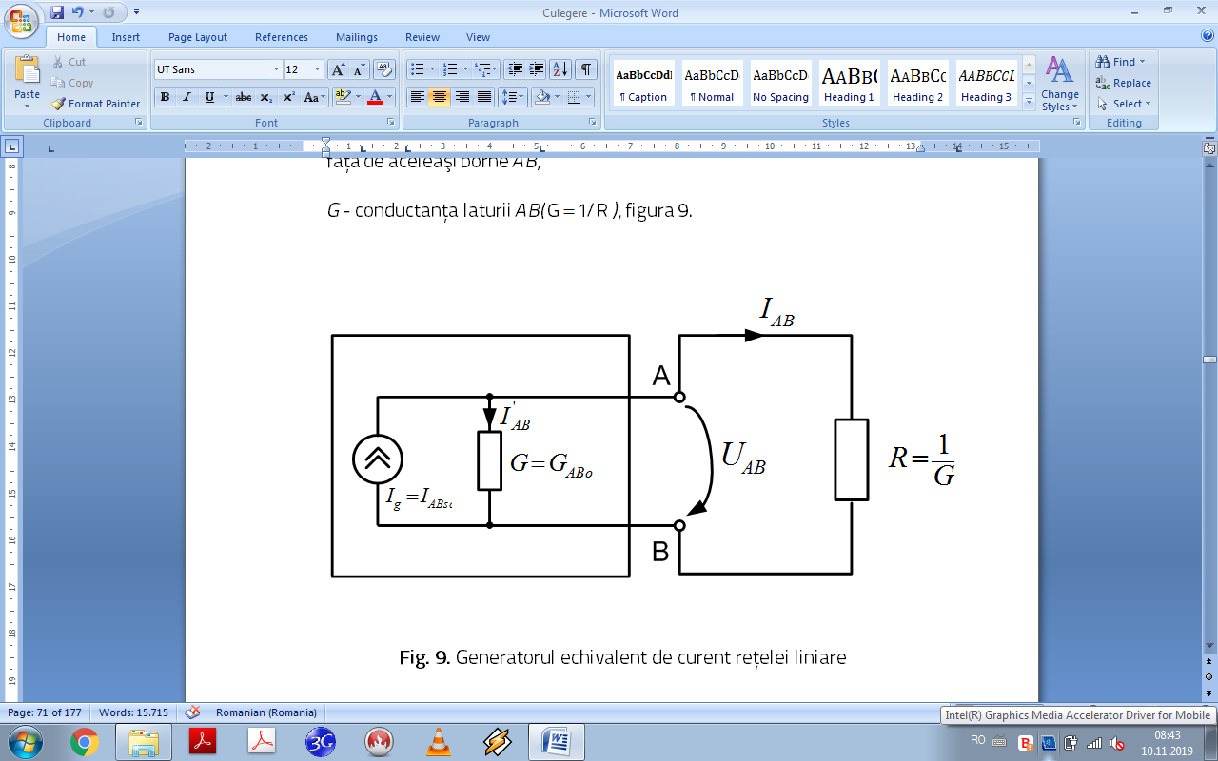

**Fig. 2. Norton Theorem**



**1. Knowing** Ue1=100V, Ue2=160V, J=10A and R6=30Ω, R2=R5=20Ω, R3=R4=10Ω determine I6 using Thevenin and UCB using Norton. Verify the results using Kirchhoffs Laws.

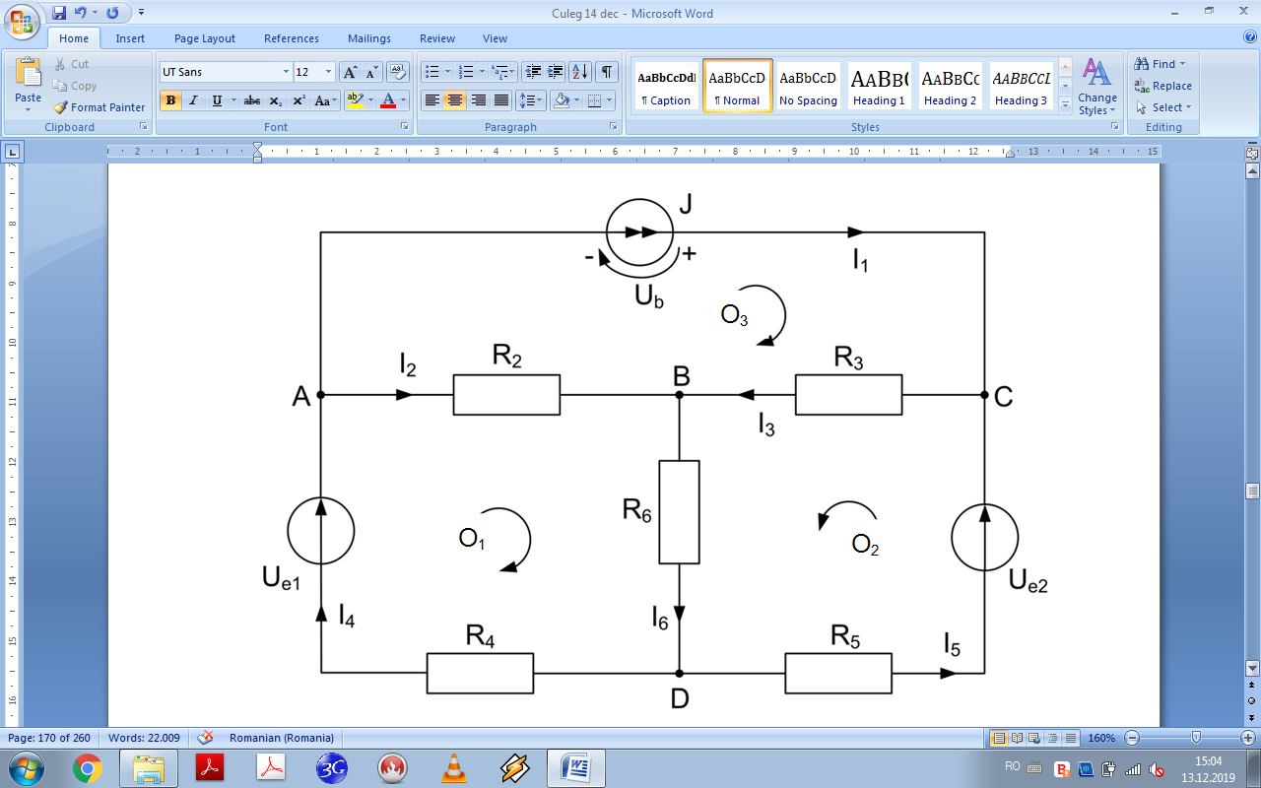

**Fig. 3a**

According to Thevenin, 

where:

UBD0 is the voltage across B and D, when we eliminate the branch BD , figure 3b,

RBD is the rezistance connected between B and D, R6 in our case,

RBD0 is the rezistance between B and D when we eliminate the branch BD and we put the sources on zero. It remains in the circuit only the rezistances and the internal rezistances of the sources (zero rezistance for ideal voltage sources and infinite rezistance for ideal current sources, figure 3c.

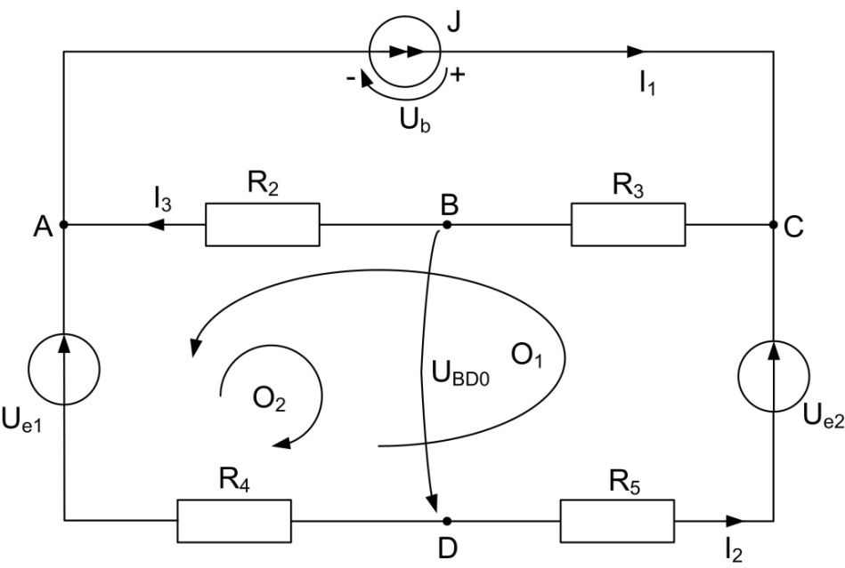

**Fig. 3b**

In order to determine UBDO, we use Kirchhoff and we obtain the system:



By replacing the known values:



We solve the system









To compute the rezistance RBD0 we use the scheme from figure 3c.

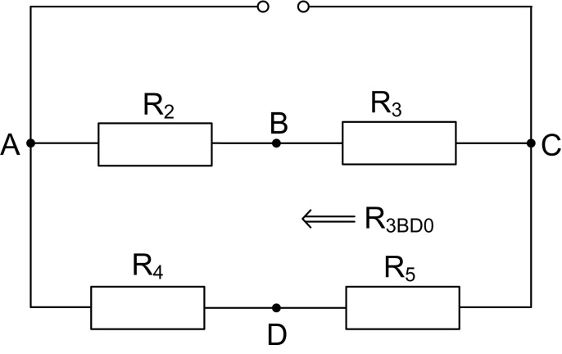

**Fig. 3c**

R2 and R4 are connected in series, also R3 in series R5 and then their branches in paralel:



Now we can compute the current:



We can verify this value using Kirchhoff in order to determine the cureents:



Replacing the values we obtain:







Results:







Then:





We obtain the values of the currents:







We obtained the same value for I6.

2. For the circuit in the figure 4a we know Ue1=133V, Ue2=98V, J=2A, R1=R3=R5=R7=3Ω, R2=R4=R6=R8=5Ω. Determine I3 with Thevenin and verify the results using Kirchhoffs laws.

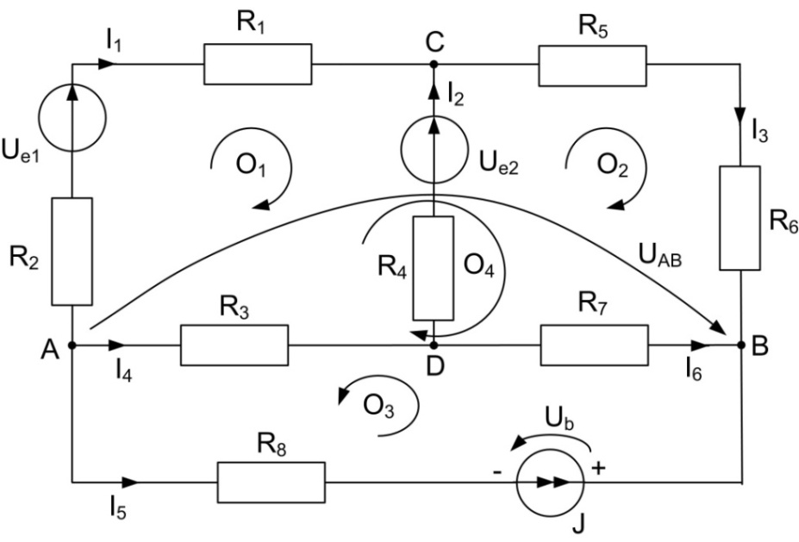

**Fig. 4a**

According to Thevenin:



where:

UCB0 is the voltage across C and B, when we elimiate the branch CB figure 4b

RCB is the rezistance connected between C and B, R6 in our circuit,

RBC0 is the rezistance between C and B when we put to zero the sources and we eliminate the branch CB, figure 4c.

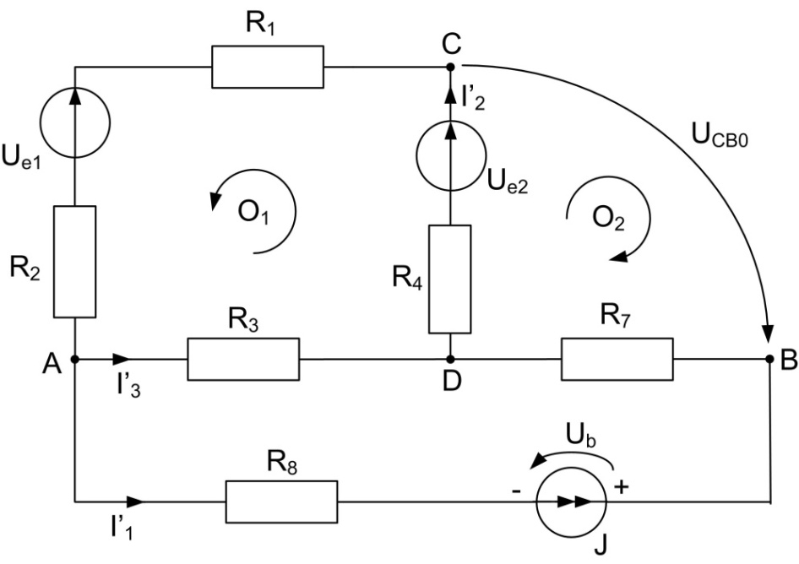

**Fig. 4b**

In order to determine the voltage UCBO, we can use Kirchhoff, and first we determine the currents in the branches.



By replacing the known values of the rezistances and voltage sources and solving the system we obtain the values of the currents:



Then using the second Kirchhoffs law in the loop O2, we can determine the voltage UCB0:



Then we compute the rezistance RBC0 using the scheme from figure 4c.

The rezistance R8 is in an open circuit so in the scheme the rezistances R1, R2 and R3 are connected in series then in parallel with R4 and then in series with R7.

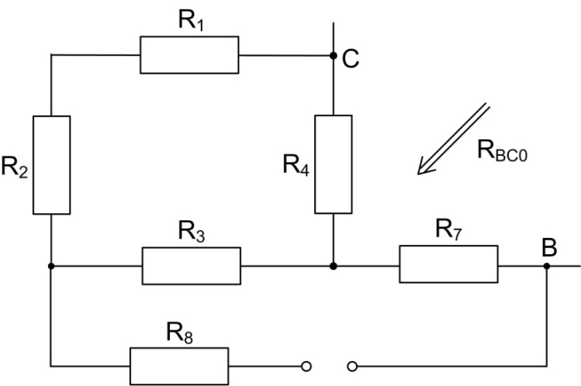

**Fig. 4c**



Now the current can be computed:



The value will be verified by computing the currents in the circuit using Kirchhoff.

The current in the branch with the current generator is already known:. 

For the node A: 

For the node B:

For the node C:

In the loop O1:

In the loop O2:

Solving the system we obtain all the currents:



We observe that the value of I3 is the same as we obtained using Thevenin.